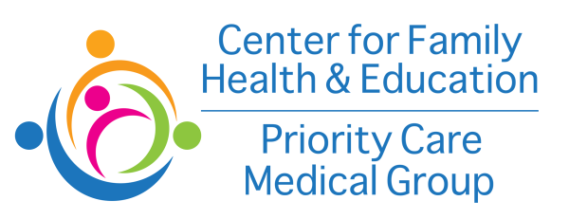

For Immediate Release

For more information, contact: Norma Hernandez
(818) 723-6111 I nhernandez@cffhae.org

American Cancer Society and the National Football League Award Grant to Center for Family Health & Education to Fight Breast Cancer and Colorectal Cancer in the Long Beach Community

Long Beach, CA – October 10, 2017 - As part of its Community Health Advocates implementing Nationwide Grants for Empowerment and Equity (CHANGE) program, the American Cancer Society has awarded a $75,000 grant to Center for Family Health & Education to implement cancer prevention and early detection activities aimed to improve cancer outcomes by providing education, outreach, navigation, and access to cancer vaccinations and screenings in Long Beach. This initiative is made possible by a partnership between the National Football League and the American Cancer Society.

The National Football League’s Crucial Catch: Intercept Cancer initiative provides funding to support increased access to cancer education, prevention and screening resources in underserved communities through the American Cancer Society.

“The NFL’s Crucial Catch allows the American Cancer Society and Center for Family Health & Education to reach the most at risk populations with cancer screenings and prevention information,” said Dan Witzling, executive director of the Society’s Los Angeles Central Coast area. “We’re proud to partner with the Center for Family Health to that end.”

Center for Family Health & Education is one of 32 cities to have a grant recipient focused on reducing the unequal burden of cancer by focusing on addressing breast cancer disparities and outcomes.

“Center for Family Health & Education is proud to be working with the American Cancer Society on eliminating health disparities and educating patients to optimize their health and well-being,” said Dr. Kashani, chief executive officer. “With the help of ACS and the NFL we will be increasing screening rates for breast cancer and colorectal cancer over the next year and a half. Our goal is to eliminate barriers to these screenings, and provide new and current patients with an opportunity to improve the quality of their health.”

Disparities predominantly arise from inequities in work, wealth, income, education, housing and overall standard of living, as well as social barriers to high-quality cancer prevention, early detection and treatment services. The Society collaborates with community health systems to reach individuals in communities with higher burdens of cancer and limited access to cancer screening.

Since 2012, CHANGE grants funded by the NFL have been awarded to community health systems to provide education, outreach, navigation and access to breast cancer screening resources within communities experiencing an unequal burden of the cancer. Collectively, grant funded health systems have provided more than 452,500 outreach and education interventions and have contributed to more than 148,300 breast cancer screenings provided at low or no cost. Thanks to our health systems grantees demonstrated impact and the NFL’s continued commitment to this life-changing work, the NFL is expanding its efforts on cancer prevention and early detection across multiple cancers in 2017. This expanded funding opportunity will continue to address breast cancer disparities while also addressing colorectal cancer, cervical cancer, or HPV vaccination. The Society’s vision is a world free from the pain and suffering of breast cancer and all cancers. Prevention and early detection programs, such as the CHANGE grant program, help to eliminate cancer-related health disparities and reach this vision.

###

About CFHE and PCMG:
The Center for Family Health & Education, Inc. (CFHE) and Priority Care Medical Group (PCMG) is a 501(c)(3) nonprofit Federally Qualified Health Center (FQHC) providing affordable and comprehensive medical care for underserved, uninsured, and underinsured residents in four Los Angeles cities (Long Beach, Mission Hills, El Monte and Panorama City). CFHE has been providing primary health care, mental health care, dental care, and women’s and children health care, as well as transportation services for patients since 2009. For more information call (818) 899-5555 or go to www.cffhae.org.

About the American Cancer Society:
The American Cancer Society is a global grassroots force of 2 million volunteers saving lives in every community. As the largest voluntary health organization, the Society's efforts have contributed to a 25 percent decline in the cancer death rate in the U.S. since 1991, driven by less smoking, better treatments and earlier detection. We're finding cures as the nation's largest private, not-for-profit investor in cancer research, ensuring people facing cancer have the help they need and continuing the fight for access to quality health care, lifesaving screenings and more. For more information, to get help or to join the fight, call us anytime, day or night, at (800) 227-2345 or visit cancer.org.

